Paint Party

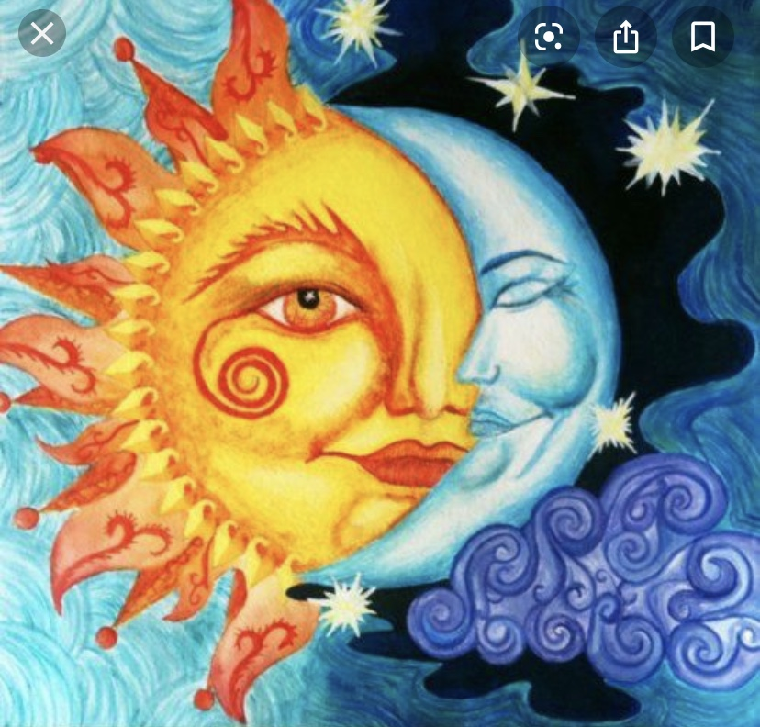

The Prospect Café

Wednesday, March 4th 2020

7pm-9pm $25

Sign-up at www.HartfordPaintParties.com